Period | Topic | Learning objectives | Language | Practical methods | Text types | Evaluation
34 - 39  41 - 46  47 - 50 | A fresh start  + read the book “The true story of the three little pigs | Explore and learn useful phrases and word to use at school needed for English lessons and communication in general  Be able to present oneself and introduce others  Be able to describe everyday life at school    Work with numbers (tell the time, the difference between AM and PM) | Sort verbs, adjectives and nouns | Story in an envelope  Interactive “tell the time” tasks  Film clips  Discussion  Fly swapper exercise  Relay race  Bleep exercise | Factual texts  Drawing  Timetables  Novel extracts | Writing:  - Hand in – “The school of my dreams”  Speaking:  - “Quest of the week”  Kartleggeren  National test in English
 | The UK | Be able to place and name the different parts of the UK on a map  Explain why the UK is a multicultural society  Describe and explore culture and traditions through f. example food and drink, sports,  Briefly go through the background history of the UK to give an understanding of why there are many different nationalities found here | Past simple  Pronunciation  British and American English | Poster carousel  Group relay race  Match city with soccer team  Make scones  Treasure Hunt  Documentary | Pictures  Map  Poem  Recipe  Factual text  Interview | Writing:  - E-mail  - Factual sum-up test  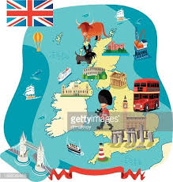  Speaking:  - Mini talk
 | Heroes | Define different types of heroes  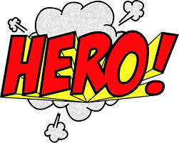  Learn about real life heroes and heroes in literature | Present simple  British and American English | Grammarman – online comic strips  Act out a script  Parts of the film “Robin Hood”  Think-pair-share  Venn-diagram | Comics  Factual text  Article  Novel extract | Writing:  - Term test (tentamen)  Speaking:  - Mini presentation – “My hero”

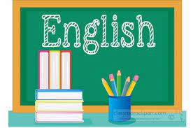
Relevance and central values: https://www.udir.no/lk20/eng01-04/om-faget/fagets-relevans-og-verdier
Interdisciplinary topics: https://www.udir.no/lk20/eng01-04/om-faget/tverrfaglige-temaer?lang=nob
Core elements: https://www.udir.no/lk20/eng01-04/om-faget/kjerneelementer
Basic skills: https://www.udir.no/lk20/eng01-04/om-faget/grunnleggende-ferdigheter

